Exp 1: Simulation and Comparative
Performance Evaluation of Zigbee, 6LoWPAN and NB-IoT Communication Protocols for IoE Applications

Objectives:To simulate and compare the performance of Zigbee, 6LoWPAN, and NB-IoT communication protocols for Internet of Everything (IoE) applications based on parameters such as data rate, latency, energy consumption, communication range, and reliability
Procedure :
- Select a suitable simulation tool and configure the network environment for Zigbee, 6LoWPAN, and NB-IoT protocols.
- Create the network topology by configuring nodes, gateways, and communication links for each protocol.
- Simulate data transmission between IoE devices using the three communication protocols under similar conditions.
- Measure and record the performance parameters, including throughput, latency, energy consumption, and packet delivery ratio.
- Compare the simulation results and identify the most suitable protocol for different IoE applications based on its performance.
Program:
import numpy as np
import pandas as pd
import matplotlib.pyplot as plt

# Comparative Performance Evaluation of IoE Protocols

np.random.seed(42)

protocols = ["Zigbee", "6LoWPAN", "NB-IoT"]
nodes = [10, 20, 30, 40, 50]

# Illustrative model parameters (not actual NS-3 results)
base = {
"Zigbee": [96, 35, 120, 18],
"6LoWPAN": [94, 50, 105, 22],
"NB-IoT": [98, 120, 180, 30]
}

results = []

for protocol in protocols:
pdr0, delay0, throughput0, energy0 = base[protocol]

for n in nodes:
load = (n - 10) / 40

pdr = max(0, pdr0 - 5 * load)
delay = delay0 * (1 + 0.6 * load)
throughput = throughput0 * (1 - 0.15 * load)
energy = energy0 * (1 + 0.25 * load)

results.append([
protocol, n, round(pdr, 2),
round(delay, 2), round(throughput, 2),
round(energy, 2)
])

# Create results table
df = pd.DataFrame(results, columns=[
"Protocol", "Nodes", "PDR (%)",
"Delay (ms)", "Throughput (kbps)",
"Energy (mJ)"
])

print("\nCOMPARATIVE PERFORMANCE RESULTS\n")
print(df.to_string(index=False))

# Save results
df.to_csv("IoE_Protocol_Results.csv", index=False)

# Plot performance graphs
metrics = [
("PDR (%)", "Packet Delivery Ratio"),
("Delay (ms)", "End-to-End Delay"),
("Throughput (kbps)", "Throughput"),
("Energy (mJ)", "Energy Consumption")
]

for metric, title in metrics:
plt.figure(figsize=(8, 5))

for protocol in protocols:
data = df[df["Protocol"] == protocol]
plt.plot(
data["Nodes"], data[metric],
marker="o", label=protocol
)

plt.xlabel("Number of Nodes")
plt.ylabel(metric)
plt.title(title + " vs Number of Nodes")
plt.legend()
plt.grid(True)
plt.tight_layout()
plt.savefig(title.replace(" ", "_") + ".png", dpi=300)
plt.show()

# Average performance comparison
print("\nAVERAGE PERFORMANCE\n")
print(df.groupby("Protocol").mean(numeric_only=True).round(2))

print("\nSimulation analysis completed.")
print("CSV results and performance graphs generated.")
Table column:
 | ZIGBEE | 6LoWPAN | NB-IoT
Pt(dBm) | 0 | 0 | 23
PL0(dB) | 40 | 40 | 31
N | 3.0 | 3.0 | 3.5
N(dBm) | -100 | -100 | -100
BER | 7.1565e^-66 | 3.578e^-66 | 0.401
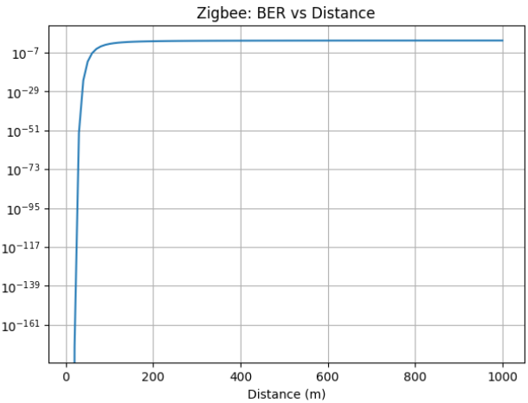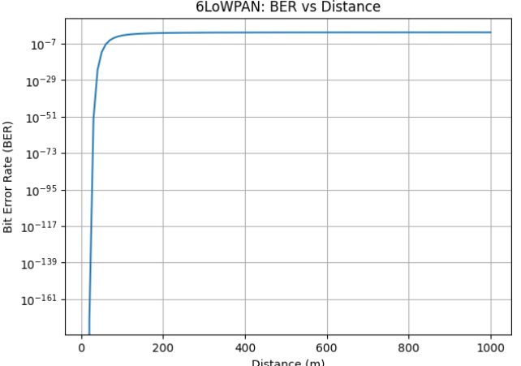

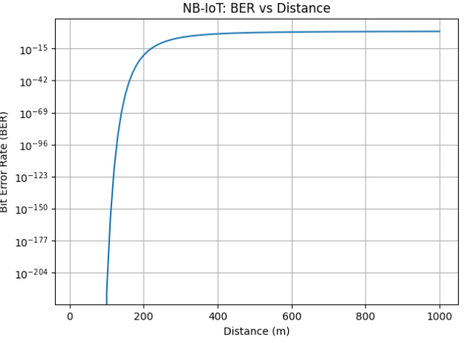
 | ZIGBEE | 6LoWPAN | NB-IoT
Pt(dBm) | 0 | 0 | 23
PL0(dB) | 40 | 40 | 31
N | 3.0 | 3.0 | 3.5
N(dBm) | -95 | -95 | -95
BER | 5.4235e^-22 | 2.712e^-22 | 0.494

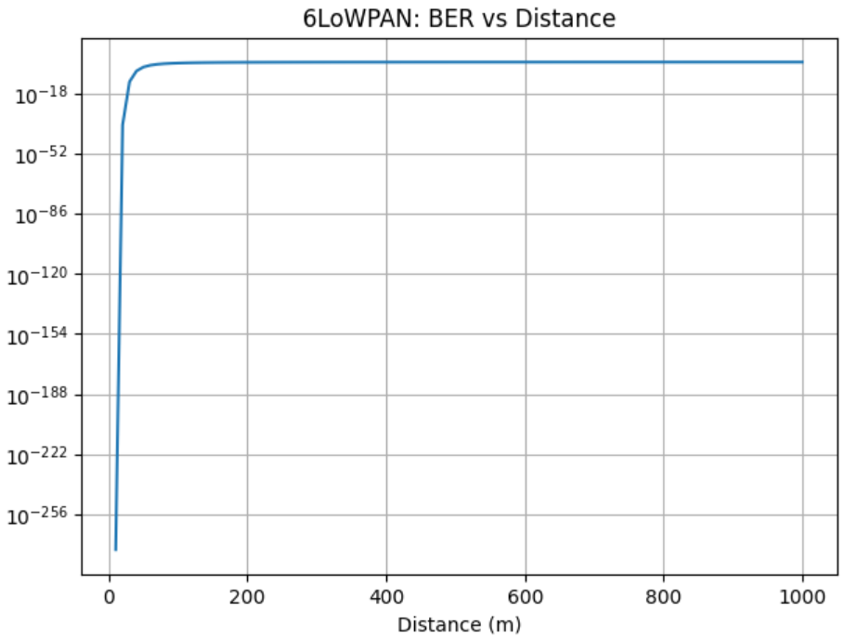
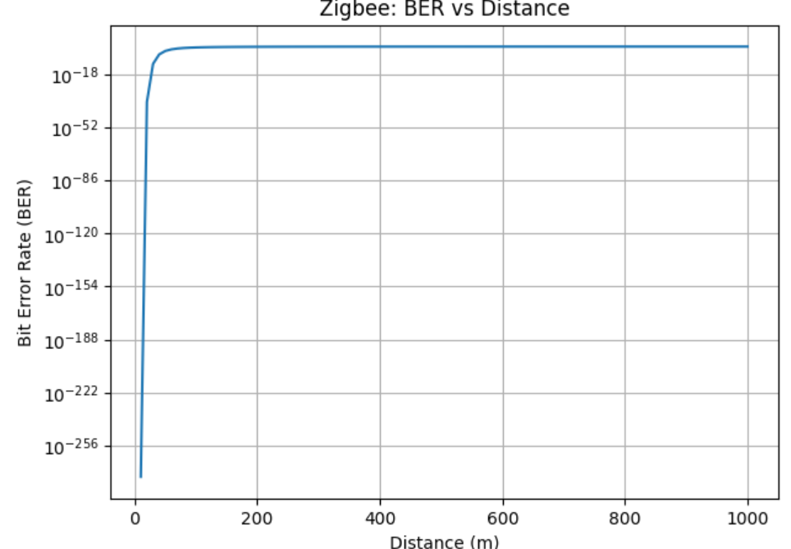
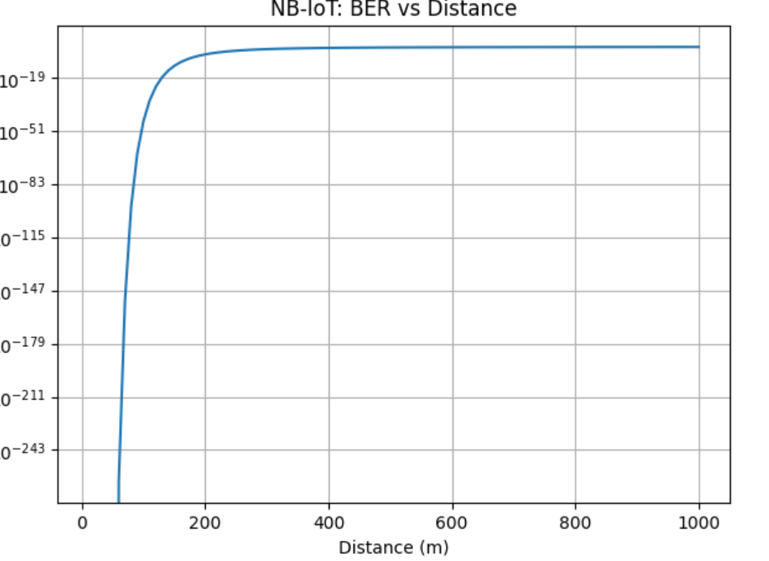
 | ZIGBEE | 6LoWPAN | NB-IoT
Pt(dBm) | 0 | 0 | 23
PL0(dB) | 40 | 40 | 31
N | 3.0 | 3.0 | 3.5
N(dBm) | -90 | -90 | -90
BER | 5.929e^-8 | 2.965e^-8 | 0.4685


